# 6h Forecast

## Model 1

model = Sequential()  
model.add(LSTM(50, return_sequences=True, input_shape=sample_input_shape))  
model.add(Dropout(0.2))  
model.add(LSTM(50))  
model.add(Dropout(0.2))  
model.add(Dense(forecast_horizon))

### Epoc 250 and LR 0.0005

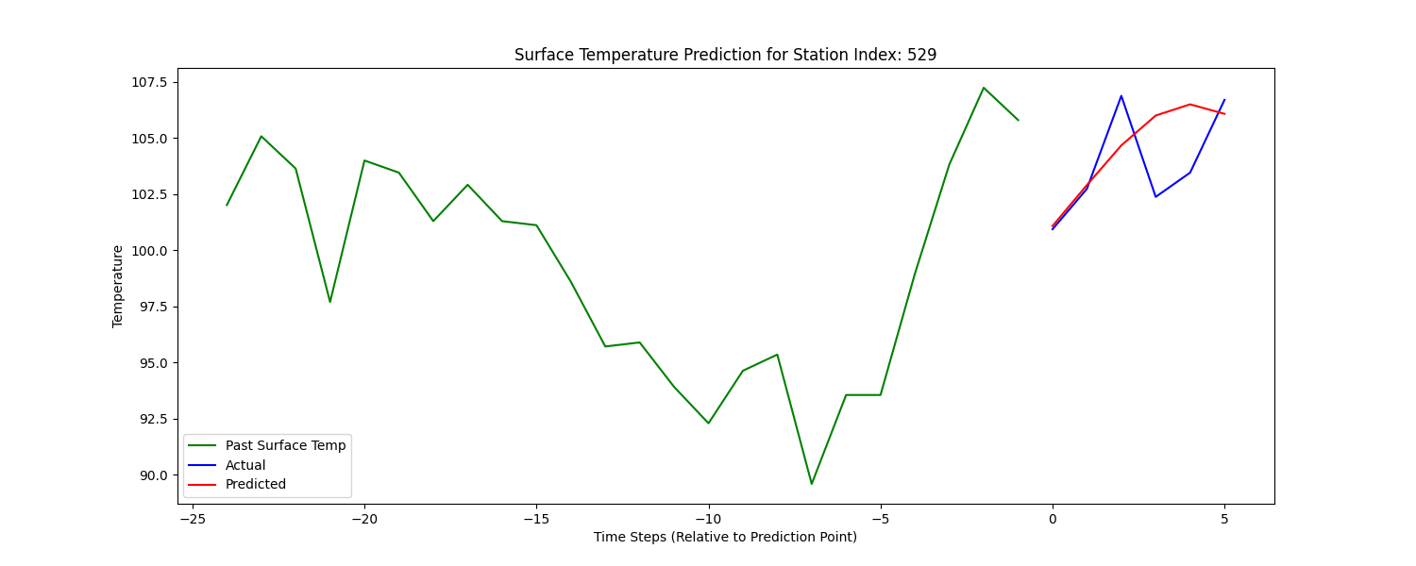

## Model 2

model = Sequential()  
model.add(Bidirectional(LSTM(100, return_sequences=True), input_shape=sample_input_shape))  
model.add(Dropout(0.3))  
model.add(BatchNormalization())  
model.add(Bidirectional(LSTM(100, return_sequences=True)))  
model.add(Dropout(0.3))  
model.add(BatchNormalization())  
model.add(Bidirectional(LSTM(100)))  
model.add(Dropout(0.3))  
model.add(BatchNormalization())  
model.add(Dense(50, activation='relu'))  
model.add(Dropout(0.3))  
model.add(Dense(forecast_horizon)) # Assuming your output size is 12  
optimizer = tf.keras.optimizers.Adam(learning_rate=LR)  
model.compile(optimizer=optimizer, loss='mean_squared_error', metrics=['mse', 'mae'])  
  
# Model Training  
history = model.fit(X_train, Y_train, epochs=Epoch, batch_size=32, validation_data=(X_val, Y_val), verbose=1)  
  
# After training the model  
model.save('RNNLSTMV1HourForecast6.h5')

### Epoc 250 and LR 0.0005

# 12h Forecast

## Model 1

model = Sequential()  
model.add(LSTM(50, return_sequences=True, input_shape=sample_input_shape))  
model.add(Dropout(0.2))  
model.add(LSTM(50))  
model.add(Dropout(0.2))  
model.add(Dense(forecast_horizon))

### Epoc 250 and LR 0.0005

## Model 2

model = Sequential()  
model.add(Bidirectional(LSTM(100, return_sequences=True), input_shape=sample_input_shape))  
model.add(Dropout(0.3))  
model.add(BatchNormalization())  
model.add(Bidirectional(LSTM(100, return_sequences=True)))  
model.add(Dropout(0.3))  
model.add(BatchNormalization())  
model.add(Bidirectional(LSTM(100)))  
model.add(Dropout(0.3))  
model.add(BatchNormalization())  
model.add(Dense(50, activation='relu'))  
model.add(Dropout(0.3))  
model.add(Dense(forecast_horizon)) # Assuming your output size is 12  
optimizer = tf.keras.optimizers.Adam(learning_rate=LR)  
model.compile(optimizer=optimizer, loss='mean_squared_error', metrics=['mse', 'mae'])  
  
# Model Training  
history = model.fit(X_train, Y_train, epochs=Epoch, batch_size=32, validation_data=(X_val, Y_val), verbose=1)  
  
# After training the model  
model.save('RNNLSTMV1HourForecast6.h5')

### Epoc 250 and LR 0.0005

# 24h Forecast

## Model 1

model = Sequential()  
model.add(LSTM(50, return_sequences=True, input_shape=sample_input_shape))  
model.add(Dropout(0.2))  
model.add(LSTM(50))  
model.add(Dropout(0.2))  
model.add(Dense(forecast_horizon))

### Epoc 250 and LR 0.0005

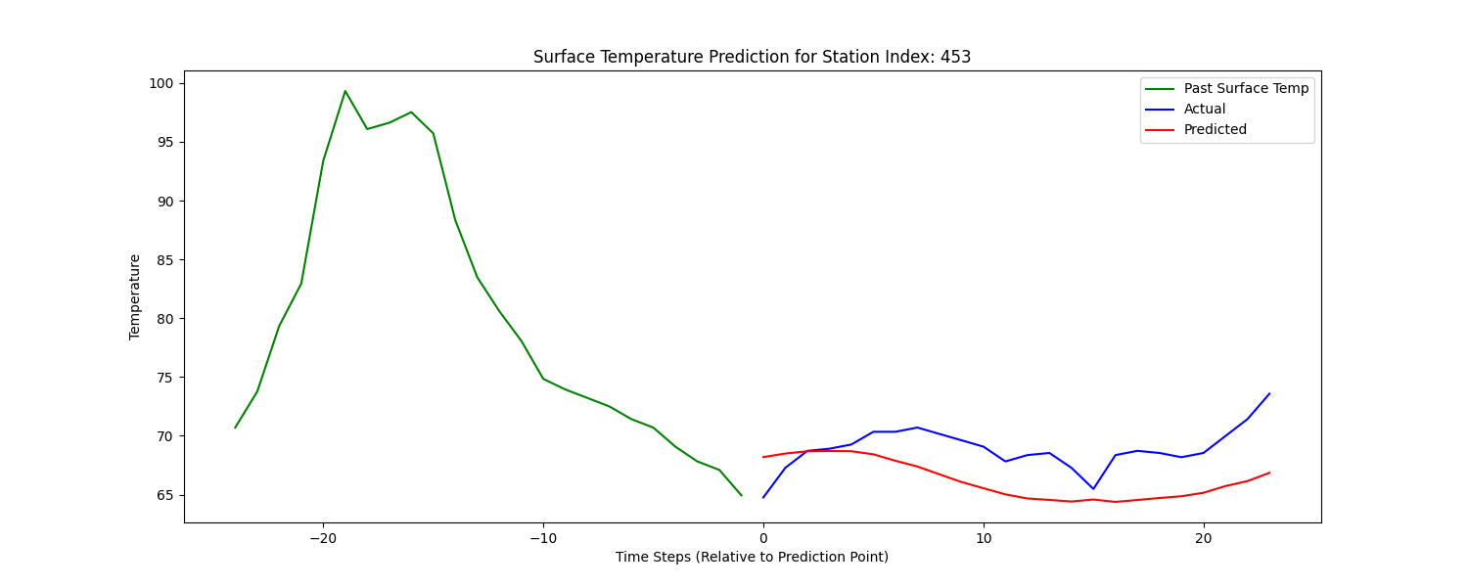

## Model 2

model = Sequential()  
model.add(Bidirectional(LSTM(100, return_sequences=True), input_shape=sample_input_shape))  
model.add(Dropout(0.3))  
model.add(BatchNormalization())  
model.add(Bidirectional(LSTM(100, return_sequences=True)))  
model.add(Dropout(0.3))  
model.add(BatchNormalization())  
model.add(Bidirectional(LSTM(100)))  
model.add(Dropout(0.3))  
model.add(BatchNormalization())  
model.add(Dense(50, activation='relu'))  
model.add(Dropout(0.3))  
model.add(Dense(forecast_horizon)) # Assuming your output size is 12  
optimizer = tf.keras.optimizers.Adam(learning_rate=LR)  
model.compile(optimizer=optimizer, loss='mean_squared_error', metrics=['mse', 'mae'])  
  
# Model Training  
history = model.fit(X_train, Y_train, epochs=Epoch, batch_size=32, validation_data=(X_val, Y_val), verbose=1)  
  
# After training the model  
model.save('RNNLSTMV1HourForecast6.h5')

### Epoc 250 and LR 0.0005

